Case Study 3:
Blackbox Test-Case Designed Techniques
1.Equivalence class partitioning (ECP)
Design Equivalence Class Partitioning for an application number field that accepts 1-500 digits
1. Range 0 to 14
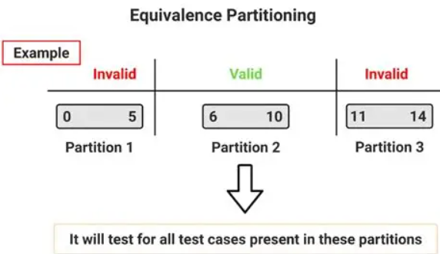
S. No | Normal Test Data | Divide values into equivalence class | Test Data Using ECP
1 | 3 | Invalid Class – 0–5 | 3
2 | 8 | Valid Class – 6–10 | 8
3 | 12 | Invalid Class – 11–14 | 12

2.Range 50 to 90
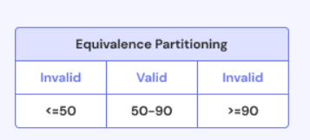
S. No | Normal Test Data | Divide values into equivalence class | Test Data Using ECP
1 | 40 | Invalid Class – <50 | 40
2 | 70 | Valid Class – 50–90 | 70
3 | 95 | Invalid Class – >90 | 95

3.Positive number range
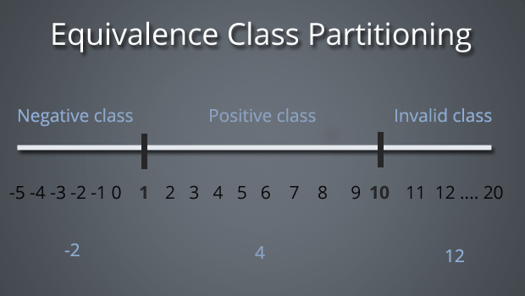
S. No | Normal Test Data | Divide values into equivalence class | Test Data Using ECP
1 | -2 | Invalid Class – Negative values (<1) | -2
2 | 4 | Valid Class – Positive values (1–9) | 4
3 | 12 | Invalid Class – Values ≥10 | 12

4. Marks / Score Validation Using Equivalence Class Partitioning
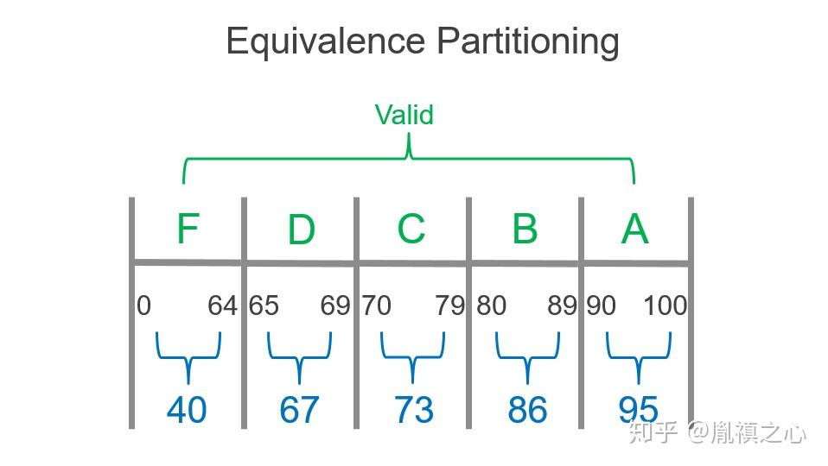
S. No | Normal Test Data | Divide values into equivalence class | Test Data Using ECP
1 | 40 | Valid Class – F Grade: 0–64 | 40
2 | 67 | Valid Class – D Grade: 65–69 | 67
3 | 73 | Valid Class – C Grade: 70–79 | 73
4 | 86 | Valid Class – B Grade: 80–89 | 86
5 | 95 | Valid Class – A Grade: 90–100 | 95

5. Age Validation Using Equivalence Class Partitioning
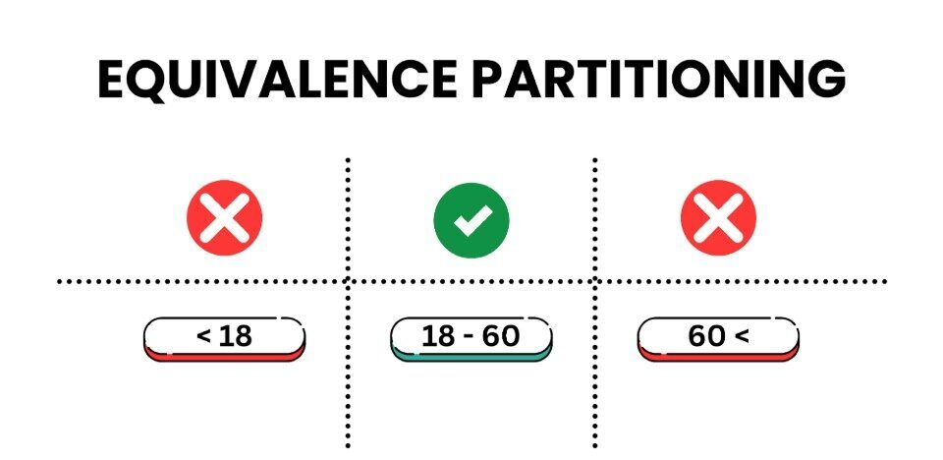
S. No | Normal Test Data | Divide values into equivalence class | Test Data Using ECP
1 | 15 | Invalid Class – Age <18 | 15
2 | 30 | Valid Class – Age 18–60 | 30
3 | 65 | Invalid Class – Age >60 | 65

